**EFFECTIVE HEART DISEASE PREDICTION USING IBM WATSON STUDIO**

**TEAM MEMBERS**

* Sneha Tingilkar
* Donikela Rahul
* Mohammed Yakub Pasha
* M.Madhava

**INTRODUCTION:**

Heart Disease describes a range of conditions that affect your heart. Diseases under the heart disease umbrella include blood vessel diseases, such as coronary artery disease, heart rhythm problems and heart defects you are born with, among others. Heart disease is one of the biggest cause of morbidity and mortality among the population of the world. Prediction of Cardiovascular disease is regarded as one of the most important subjects in the section of clinical data analysis. But it is very difficult to identify heart disease because of several contributing factors such as diabetes, high blood pressure, high cholesterol, abnormal pulse rate and many other factors. Due to constraints, scientists have turned towards modern approaches like Data Mining and Machine Learning to predict the disease. Machine Learning proves to be effective in assisting in making decisions and predictions from the large quantity data produced by the health industry.

**LITERATURE SURVEY**:

Improved Study of Heart Disease Prediction System using Data Mining Classification Techniques. Published in International Journal of Computer Applications 2017. Author: Chaitrali S. Dangare This paper has analysed prediction systems for Heart disease using more number of input attributes. Until now, 13 attributes are used for prediction. This research paper added two more attributes i.e. obesity and smoking. The data mining classification techniques, namely Decision Trees, Naive Bayes, and Neural Networks are analysed on Heart disease database. The performance of these techniques is compared, based on accuracy. As per our results accuracy of Neural Networks, Decision Trees, and Naive Bayes are 100%, 99.62%, and 90.74% respectively. Our analysis shows that out of these three classification models Neural Networks predicts Heart disease with highest accuracy.

Heart Disease Prediction using Data Mining with Map reduce Algorithm Published in International Journal of Innovative Technology and Exploring Engineering (IJITEE) 2019 Authors: T. Nagamani, S. Logeswari, B. Gomathy In the proposed system, large set of medical instances are taken as input. From this medical dataset, it is aimed to extract the needed information from the record of heart patients using MapReduce technique. The performance of the proposed MapReduce Algorithm’s implementation in parallel and distributed systems was evaluated by using Cleveland dataset and compared with that of the predictable ANN method. The trial results verify that the projected method could achieve an average prediction accuracy of 98%, which is greater than the conventional recurrent fuzzy neural network. In addition, this MapReduce technique also had better performance than previous methods that reported prediction accuracies in the range of 95– 98%. These findings suggest that the MapReduce technique could be used to accurately predict HD risks in the clinic.

**EXISTING PROBLEM:**

In this system, the input details are obtained from the patient. Then from the user inputs, using ML techniques heart disease is analyzed. Now, the obtained results are compared with the results of existing models within the same domain and found to be improved. The results are compared for performance and accuracy with these algorithms.

**SOLUTION:**

After evaluating the results from the results from the existing methodologies, we have used python and pandas operations to perform heart disease classification for the data obtained from the dataset. It provides an easy-to-use visual representation of the dataset, working environment and building the predictive analytics. ML process starts from a pre-processing data phase followed by feature selection based on data phase followed by feature selection based on data cleaning, classification of modelling performance is used to improve the accuracy of the result.

**HARDWARE/SOFTWARE REQUIREMENTS:**

**Hardware Requirements:**

• Processor: Minimum 1 GHz; Recommended 2GHz or more.

• Ethernet connection (LAN) OR a wireless adapter (Wi-Fi)

• Hard Drive: Minimum 32 GB; Recommended 64 GB or more.

• Memory (RAM): Minimum 1 GB; Recommended 4 GB or above.

**Software Requirements:**

• Python (3.7 or older)

• Anaconda Prompt

• Watson Studio Service

• Visual Studio

• Flask

**EXPERIMENTAL INVESTIGATIONS:**

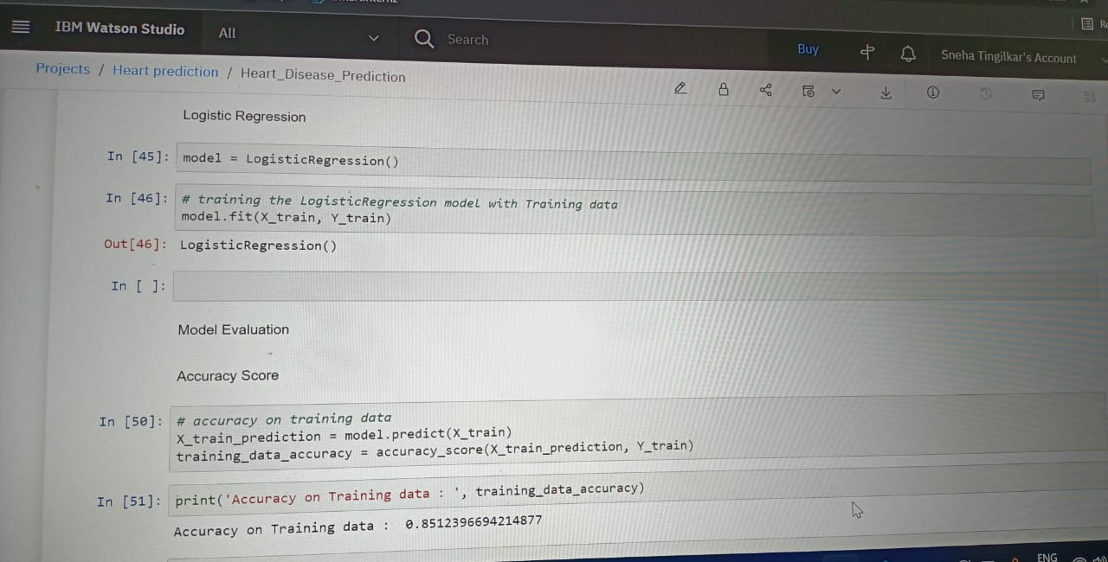

**FLOW CHART:**

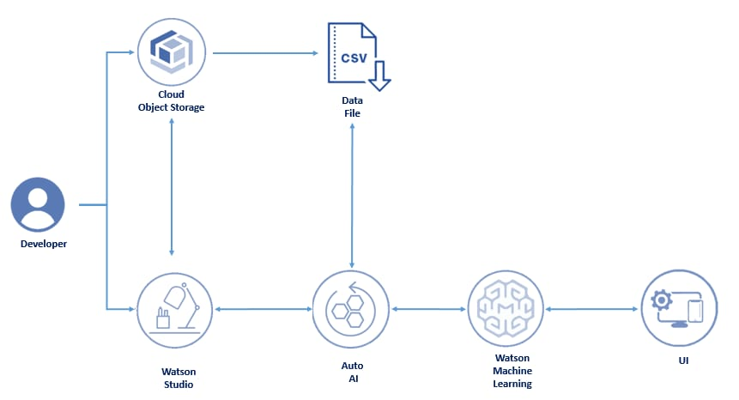

**ADVANTAGES & DISADVANTAGES:**

**Advantages:**

* Increased accuracy for effective heart disease diagnosis.
* Handles roughest(enormous) amount of data using logistical regression and feature selection.
* Reduce the time complexity of doctors.
* Cost effective for patients.

**Disadvantages:**

* Prediction of cardiovascular disease results is not accurate.
* Data mining techniques does not help to provide effective decision making.
* Cannot handle enormous datasets for patient records.

**CONCLUSION:**

Based on the accuracy levels of all five algorithms used, namely, K-neighbours classifier, support vector classifier, decision tree classifier and random forest classifier and finally the neural net classifier, it is evident that the neural net classifier scored the best score and therefore has the highest accuracy. This project, heart disease prediction has a great scope since neural net classifier can predict if a person will have heart disease or not with an accuracy of 88%. Machine Learning is used across many spheres around the world. The healthcare industry is no exception. Machine Learning can play an essential role in predicting presence/absence of locomotor disorders, Heart diseases and more. In this project, we will be predicting potential Heart Diseases in people using Machine Learning algorithms. The algorithms included are K Neighbours Classifier, Support Vector Classifier, Decision Tree Classifier and Random Forest Classifier. We can use this result, to build future models where we use Neural Networks for prediction of Heart Diseases for new patients on the basis of patient’s health record and vitals. Further research can be made in this model to increase the accuracy and/or precision so that this model becomes more efficient.

**FUTURE SCOPE:**

In the future, the research will be continued to obtain the data from all over the country, not only west java province, and with the use of more complete analysis, so that the government or related institution could make a better anticipation work as a mitigation effort.

**BIBILOGRAPHY:**

[1] Improved Study Of Heart Disease Prediction System Using Data Mining Classification Techniques. Published In International Journal Of Computer Applications 2017. Author: Chaitrali S. Dangare

[2] Heart Disease Prediction Using Data Mining With Mapreduce Algorithm Published In International Journal Of Innovative Technology And Exploring Engineering (Ijitee) 2019 Authors: T.Nagamani, S.Logeswari, B.Gomathy

[3] Heart Disease Prediction Using Data Mining Techniques Published In Ictact Journal On Soft Computing 2018 Authors: H. Benjamin Fredrick David And S. Antony Belcy

[4] Effective Heart Disease Prediction Using Hybrid Machine Learning Techniques Publisher: Ieee Authors: Senthilkumar Mohan ; Chandrasegar Thirumalai ; Gautam Srivastava

[5] Intelligent Heart Disease Prediction System Using Data Mining Techniques Https://Ieeexplore.Ieee.Org/Abstract/Document/4493524

[6] Coronary Artery Calcium Score And Risk Classification For Coronary Heart Disease Prediction Https://Jamanetwork.Com/Journals/Jama/Article-Abstract/185757

[7] Intelligent Heart Disease Prediction System Using Canfis And Genetic Algorithm Http://Citeseerx.Ist.Psu.Edu/Viewdoc/Download?Doi=10.1.1.451.9421&Rep=Rep1&Type =Pdf

[8] Prediction System For Heart Disease Using Naive Bayes Https://Pdfs.Semanticscholar.Org/D32e/E90a5de89093a4fc95f43e0409cb91414726.Pdf

[9] Prediction Of Heart Disease Using Classification Algorithms Http://Www.Iaeng.Org/Publication/Wcecs2014/Wcecs2014_Pp809-812.Pdf

[10] HDPS: Heart disease prediction system Publisher: IEEE https://ieeexplore.ieee.org/abstract/document/6164626